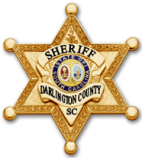
DARLINGTON COUNTY SHERIFF’S OFFICE
Sheriff Michael August
www.darcosc.com

FOIA REQUESTS
In order to help offset the costs of searching for, retrieval, and redaction of public records from the Darlington County Sheriff's Office, the following fee schedule applies:

Hourly Staff Time: $23 per hour (searching, printing, redacting, etc.)
Copies of documents: $0.25 per page (8.5 x 11)
$1.00 per page (oversized copies)

Denied Requests: $0
No records found: $0

The full balance must be paid at the time of production of the records.

Inspection, copying and production of records are subject to all applicable exemptions, redaction, and/or exclusions provided by FOIA or other state or federal laws. PURSUANT TO S.C. CODE ANN. 30-2-50, OBTAINING OR USING PUBLIC RECORDS FOR COMMERCIAL SOLICITATION DIRECTED TO ANY PERSON IN THE STATE OF SOUTH CAROLINA IS PROHIBITED, AND IS PUNISHABLE BY A FINE OF UP TO $500 AND IMPRISONMENT UP TO ONE YEAR, OR BOTH.

